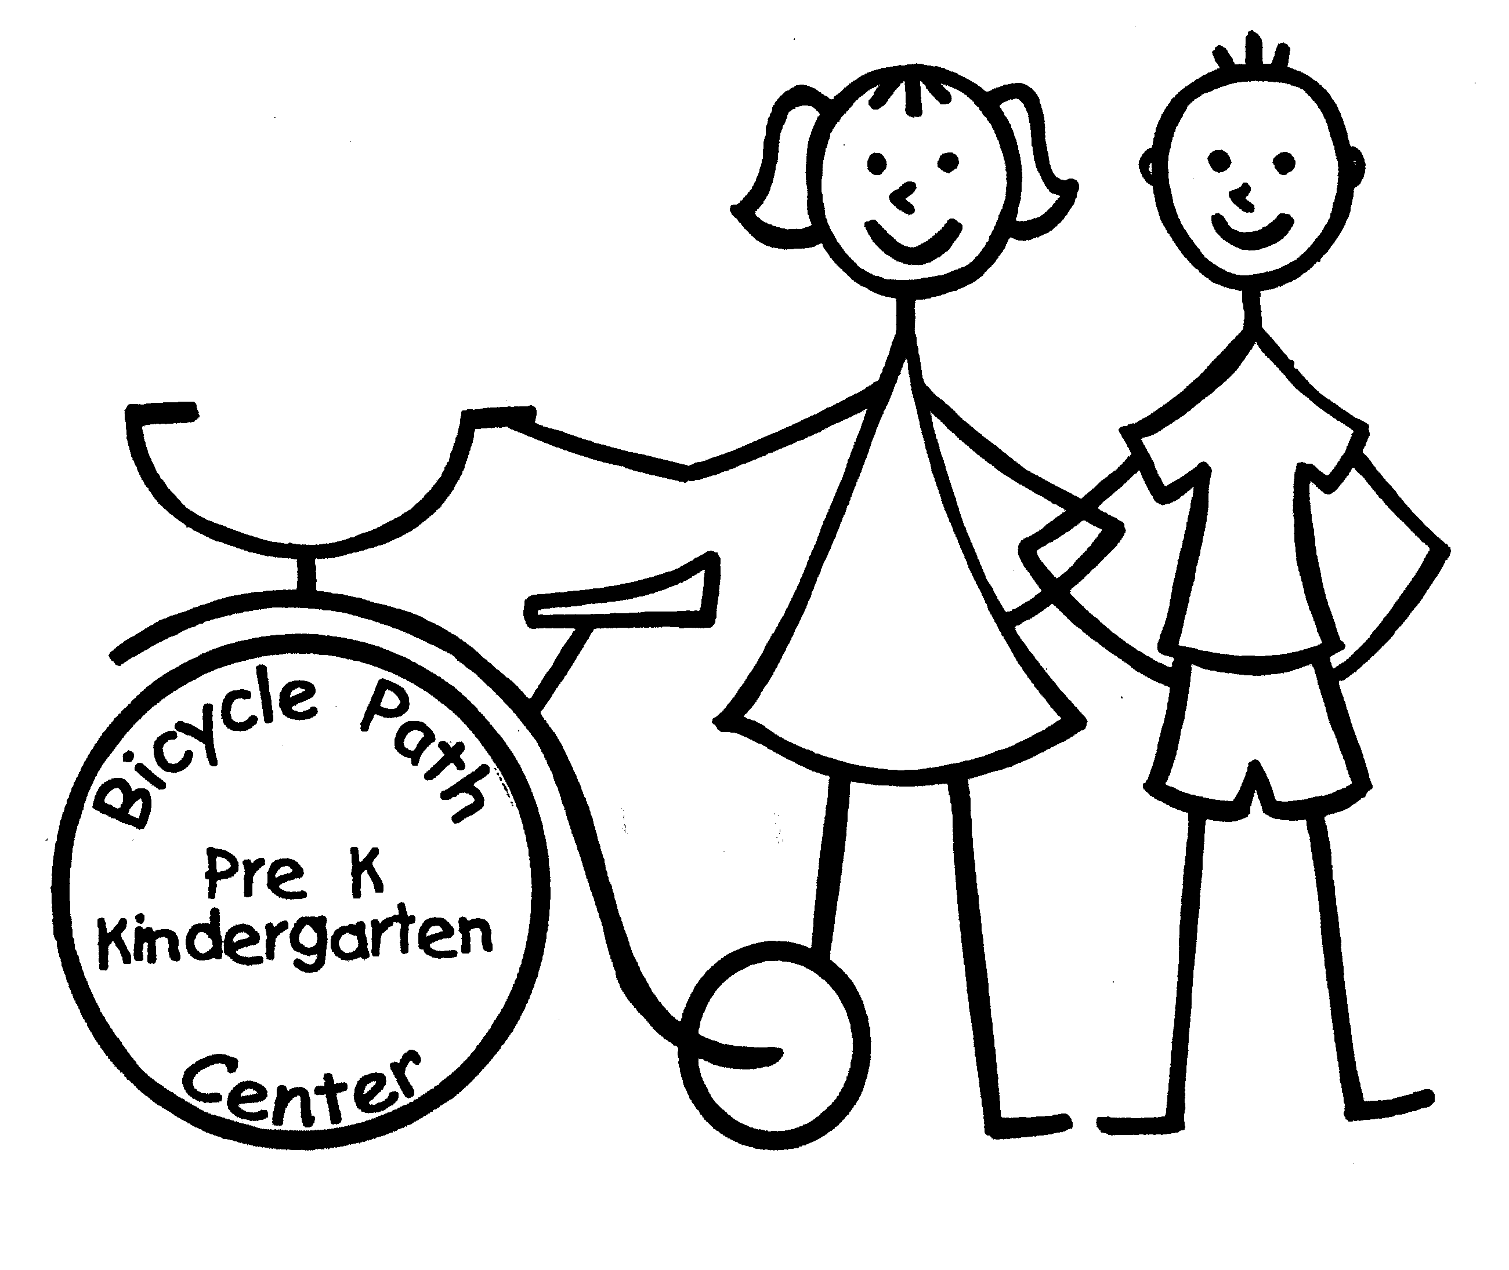 BPS Kindergarten Generic Supply List

The following list contains basic items your child will need for a successful kindergarten year. This is only a generic list. Once your child receives their assigned classroom/teacher in August, additional items will be found listed under each individual teacher on our website.
- Backpack (large enough to fit folders, notebook, Chromebook and lunch box) 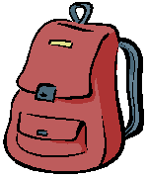
  - Backpacks cannot have wheels, please!
- 2 bottom-pocket folders (preferably plastic, but vinyl coated will work) 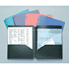
- 12 sharpened #2 Ticonderoga pencils (regular yellow outside) 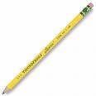
- 1 box of Crayola Crayons (24 count) 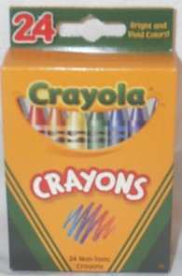
- 2 yellow highlighter markers 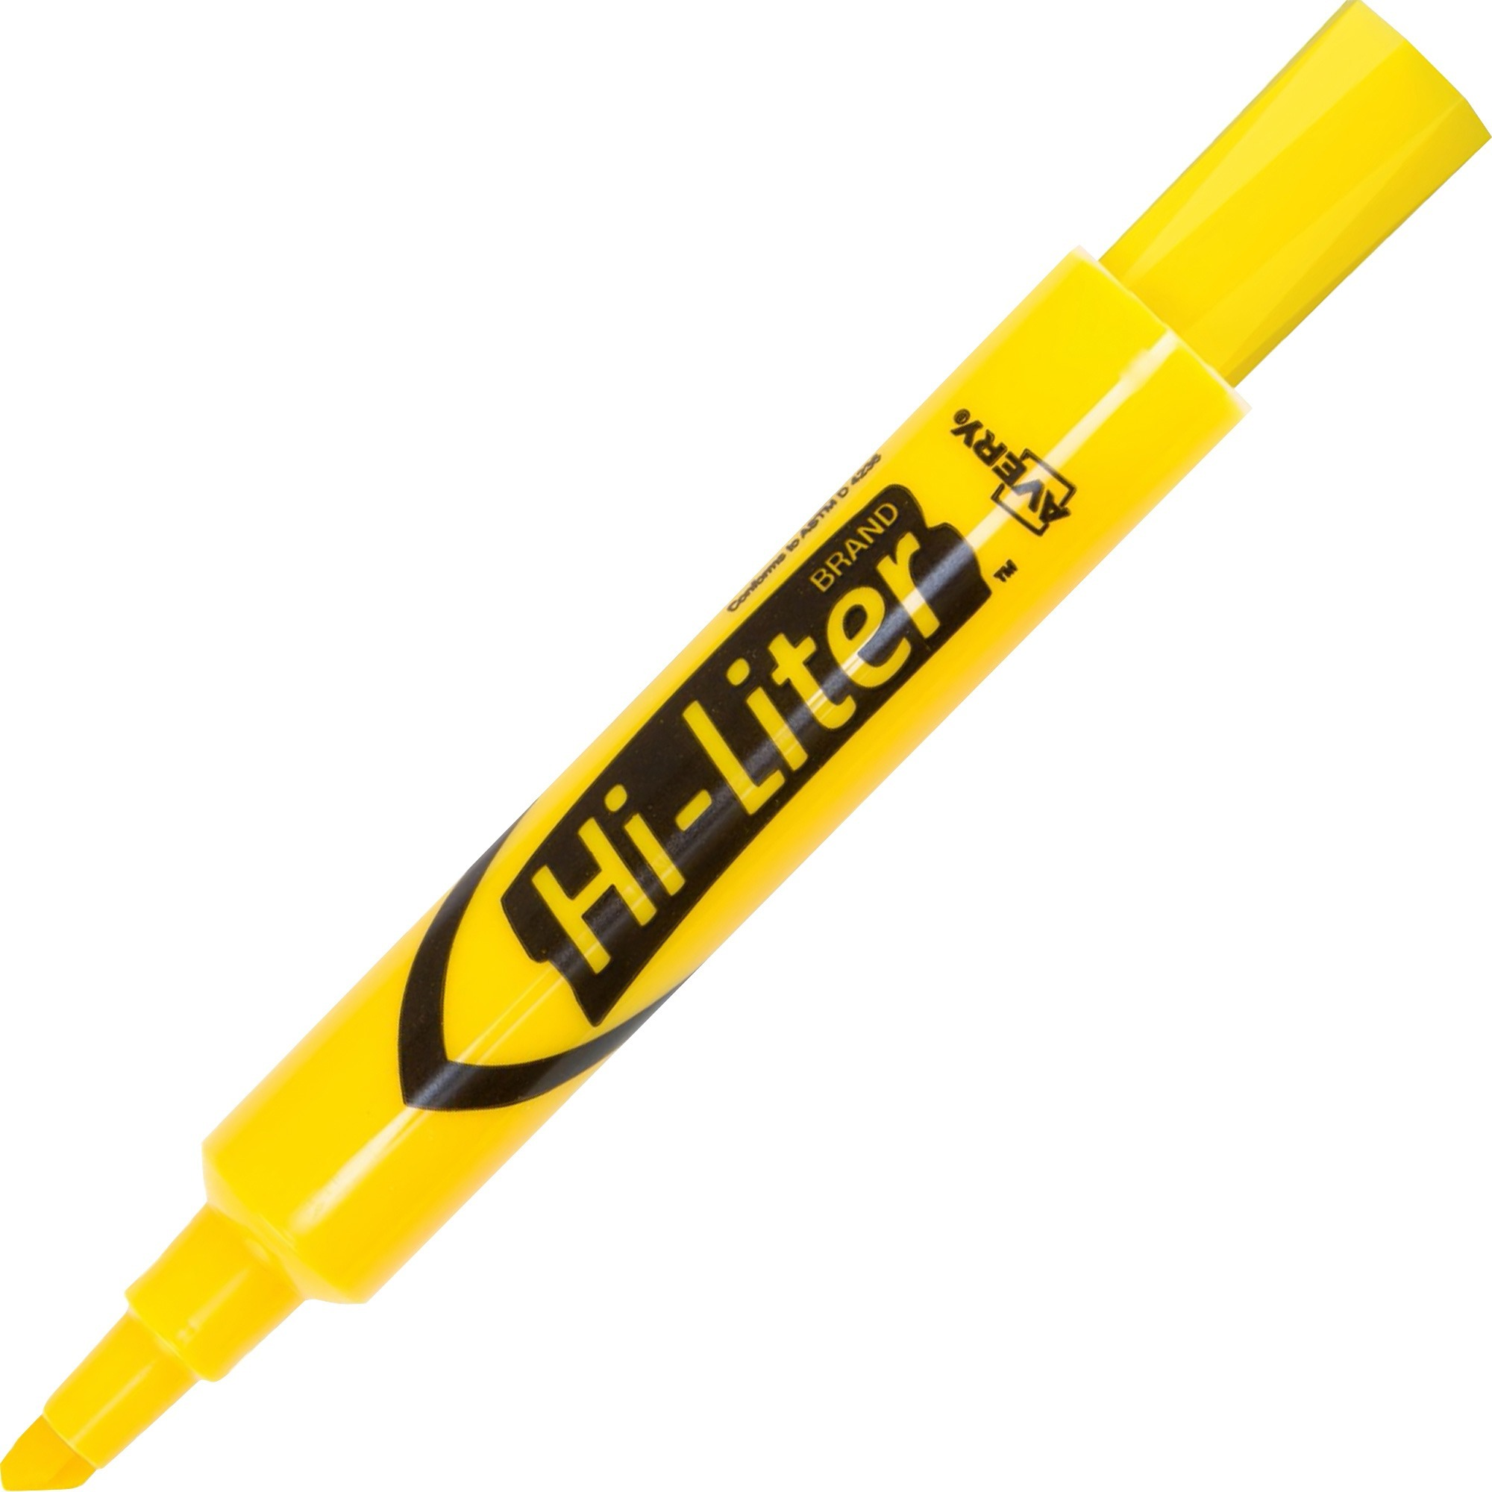
- 1 large Elmer’s glue stick (.77 oz) 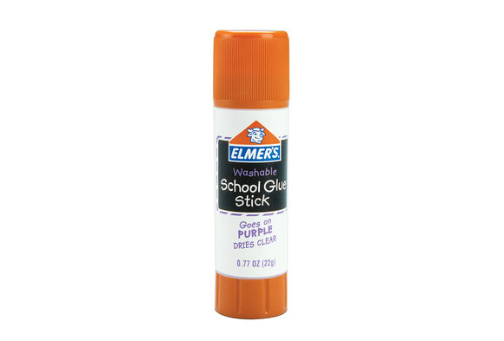
- 1 pair of blunt point Fiskars scissors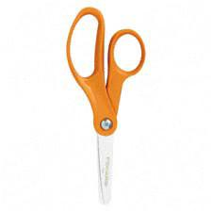
- 1 child-sized lunch box (easy to carry or to fit inside backpack) 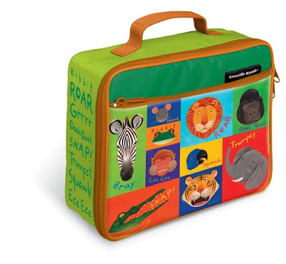
- 1 pink eraser 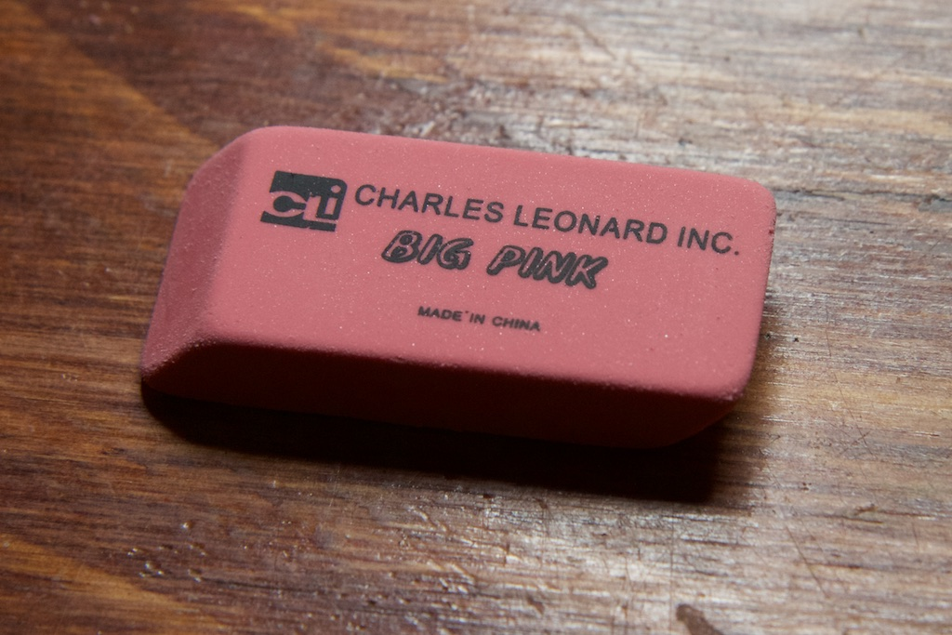
- 1 pair of computer headphones (headset over ears, please. No ear buds.) 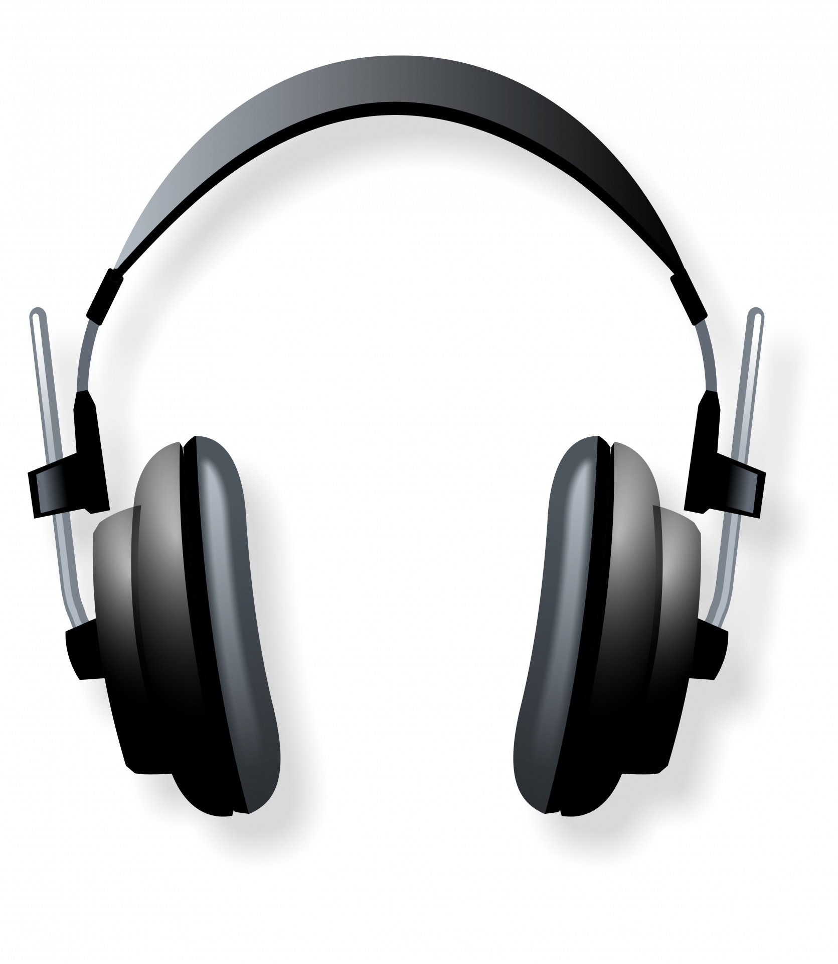

- All students will need one complete change of seasonal clothes placed in a Ziploc bag. Please label with your child’s name on the outside of the bag as well as on all articles of clothing. These will need to be replenished as needed or with the season changes.

**Please be sure to label ALL items with child’s name and room number. Supplies can be sent in a little at a time the first week of school.
**Your child’s teacher may ask for additional supplies to be replenished as they are used.

